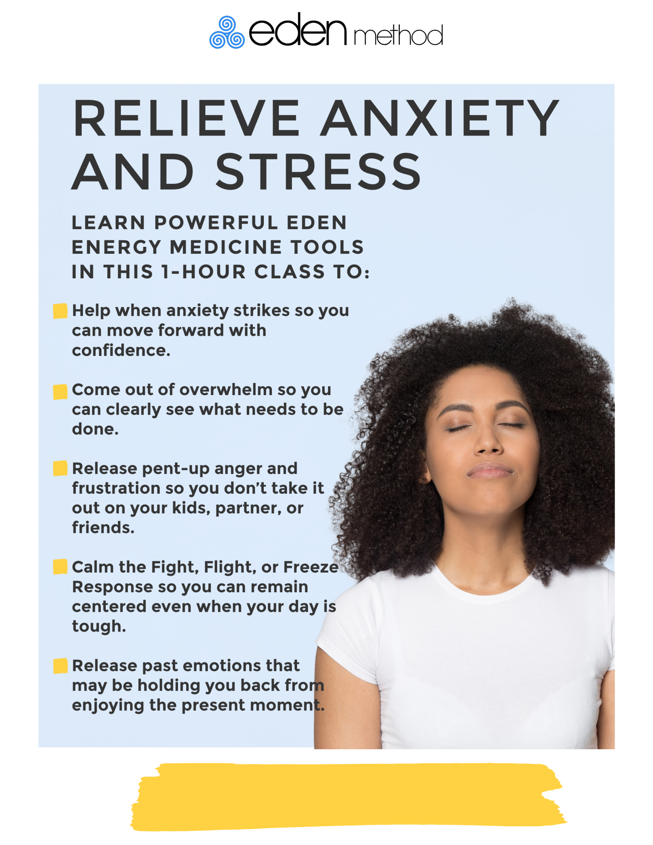

**Zoom On-line Class**

**Karen Paulosky Benton RN, HNB-BC, HTP, EEM-CLP - Eden Method Certified Teacher**

**Pick a date that works for you:**

**Monday January 24, 2022 10-11 am EST or Monday April 25, 2022 1- 2pm EST**

**Register by contacting me at** [**Energetichealingrn@gmail.com**](mailto:Energetichealingrn@gmail.com) **231-590-9758**

**Cost: $25 USD (includes handout)**