Energy Medicine 101 & 102
August 17&18, 2019
Cornelius, NC (20 minutes north of Charlotte, NC)

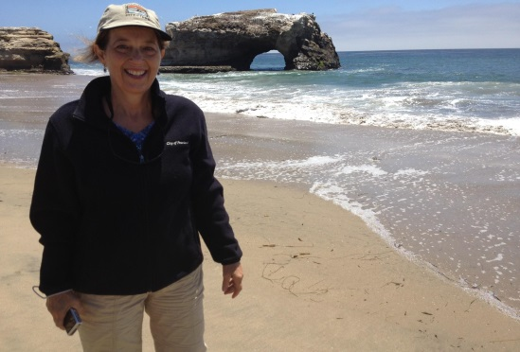
Would you like to learn the basics of Eden Energy Medicine (EEM) in a fun, supportive environment? If so, these two classes are for you! They are straight forward, easy, and full of information to help you take better care of yourself and help others do the same.
Taught sequentially, EM101 and EM102 are each one-day classes that cover many of the key topics from Donna Eden's award-winning book, Energy Medicine. The information you gain from these two classes will help you feel and be your best.
EM101 introduces EEM basics plus many topics that are important for self-care and healing. In this class you will learn, a Daily Energy Routine (just over 5 minutes) which will help you to enhance your immune system, increase your vitality, improve your memory and bring more joy into your life. You will learn how to work with meridians, the rivers of energy which flow through the body, and how to use neurovascular and neurolymphatic reflex points. You will also learn about grounding, why it is important and how to stay well grounded. This focus of EM 101 is on self-health care; although, many of the techniques that you will learn in this class can also be used to help others.
EM102 picks up where EM101 leaves off and offers important techniques for pain management and stress relief. You will learn the fundamentals of energy testing, an opportunity to learn what the energies flowing through your body can tell you. Just like EM101, this class is full of practice, and it culminates with each participant experiencing an EEM mini-session that balances and calms their energy systems. EM 101 is a prerequisite for EM102.
The classes will be taught by Betsy Keller. Betsy is a Licensed Massage Therapist NCLMBT #11974 and an Eden Energy Medicine Certified Practitioner and TA for Donna Eden. She has been teaching Eden Energy Medicine Classes since 2006.
To register for the class: www.ncmassageschool.com
For information on the class, contact Betsy Keller at (828) 269-6340 kellerbetsy@yahoo.com or go to her website www.ncenergymedicineworks.com

EM 101: EM 102:
Date: Saturday, March 30 Date: Sunday, March 31
Time: 9:00 am – 4:30 pm Time: 9:00 am- 4:30 pm
Location:
NC Massage School, 20525 N. Main Street Cornelius, NC 28031
(704) 896-2636
The class is available to everyone and Continuing Education Credits are available for NC Licensed Massage Therapists
Cost per Class: $125.00 and a $10.00 processing fee (per class) for CE Credits.

Innersource is approved by the NCBTMB as a continuing education Approved Provider (450052-06). Approved courses are labeled and the contact hours may be used for required certification for massage therapists. 12 CEU Credits are available to Licensed Massage Therapists (6 per class)

