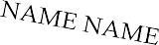  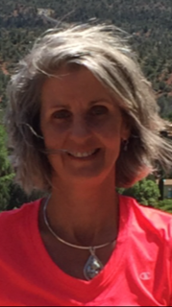  E d e n | E n e r g y | M e d i c i n | e
 | 1 0 1 & | 1 0 2

Saturday and Sunday, December 7th & 8th, 2019 Blairsville, GA
9:00 AM – 4:00 PM

What you will learn…
A 5 minute daily routine that will help improve your energy
How to stay grounded
Effects of stress on your energies, and how to lessen its effects
How to protect your Aura
Pain releasing techniques
Energy testing on yourself and others, …
And much, much more!

“It’s simple. When our energies are healthy and balanced, we feel stronger, happier, and better able to handle whatever is happening in our life.”
Donna Eden

EEM101 and 102 is taught by Cynthia Campbell. She is an Advanced Practitioner of Eden Energy Medicine and is passionate about empowering others with this work. In addition to EEM, she is a Holy Fire Reiki Master and skilled in many other healing modalities. Her practice is located in Blairsville, GA and she offers sessions in office and remote.

Pre-registration is required. Please contact Cynthia at 404.316.8836 or cynthia.revive@gmail.com for further information.
Cost: $250 for EEM101 and 102 or $125 for EEM101 only Blairsville, GA
Register early! Space is Limited!

