Presented by Starlight Wellness

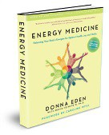

Learn Eden Energy Medicine

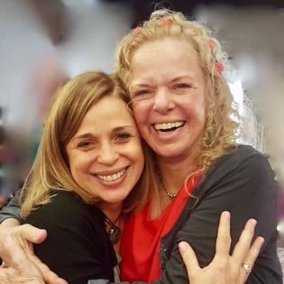

Dates: EM101A- Aug 28th EM101B- Aug 29th

EM102A- Sept 18th EM102B- Sept 19th

Time: Wed & Thurs
Evenings, 6-9:30pm
(6 hrs. of instruction for each class.
Snacks Provided.)

For EM101 only:

Cost: $125

For EM101/102:
Cost: $200
($50 discount when you register for both classes!)

Location:

291 Cedar Ave

Islip, NY 11751

For more information

and to register, contact: Debbie Chalifoux

Phone: 516-398-6620
starlightwellnessli@gmail.com

Deborah A. Chalifoux, MA, CCC-SLP, EEM-AP, RMT is an Advanced Practitioner and Authorized Instructor of Eden Energy Medicine. For Debbie’s complete bio, see the Certified Practitioner Directory on the Eden Energy Medicine Website, www.innersource.net/em.

Join Debbie for a joyful, gentle introduction to the world of Energy Medicine. Empower yourself to balance the flows of energy in your body for maximum healing and vitality in a fun, supportive, small-group setting.
Vitality, Health and Joy!

EM101 introduces the basics of EEM and includes:
♦Five-minute “Daily Energy Routine”
♦Stress Management
♦Tools for Releasing Negative Emotions
♦How to stay Grounded and Centered
♦How to Remove Toxins using Reflex Points

EM102 gives you more techniques to use with yourself and others:
♦How to work with the Auric Field
♦Learn to energy-test food and supplements
♦Pain Management
♦Learn powerful energy balancing protocols to use with others
♦Lots of “hands-on” and practice…

“It’s simple. When our energies are healthy and balanced, we feel stronger, happier, and better able to handle whatever is happening in our life.” Donna Eden
Donna’s award-winning book “Energy Medicine”

