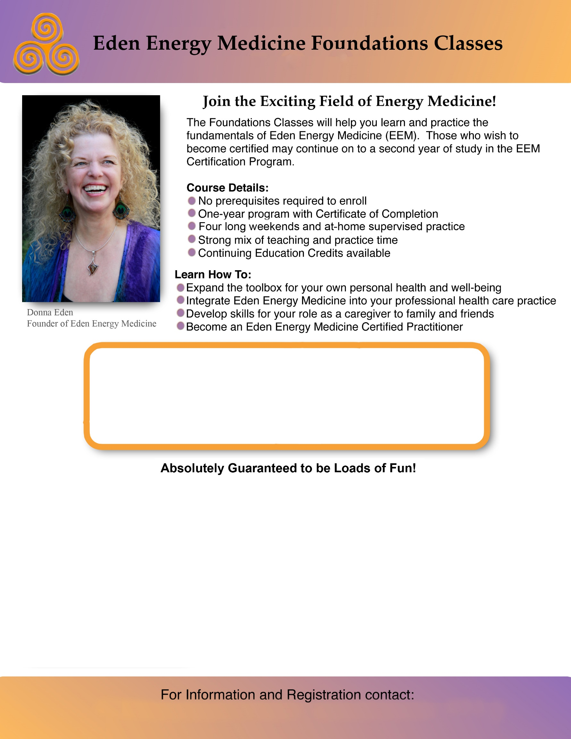

Peggy at [peggy@healconnect.com](mailto:peggy@healconnect.com) or Janel at janel@janelvolkhubbard.com

Location: Cleveland, Ohio  
Dates: Class 1: 5/16-19/19 Class 3: 11/7-10/19  
 Class 2: 8/15-18/19 Class 4: 1/23-26/20

 

**Your Instructors:**

**Janel Volk Hubbard, EEM-AP, is an Advanced Eden Energy Medicine Practitioner and EEM Faculty Member. For more information, go to** [**www.janelvolkhubbard.com**](http://www.janelvolkhubbard.com) **or call 216-462-0526.**

**Peggy Koelliker, EEM-AP, is an Advanced Eden Energy Medicine Practitioner and EEM Foundations Instructor. For more information, go to** [**www.healconnect.com**](http://www.healconnect.com) **or call** **440-930-5785.**

Peggy at [peggy@healconnect.com](mailto:peggy@healconnect.com) or Janel at janel@janelvolkhubbard.com