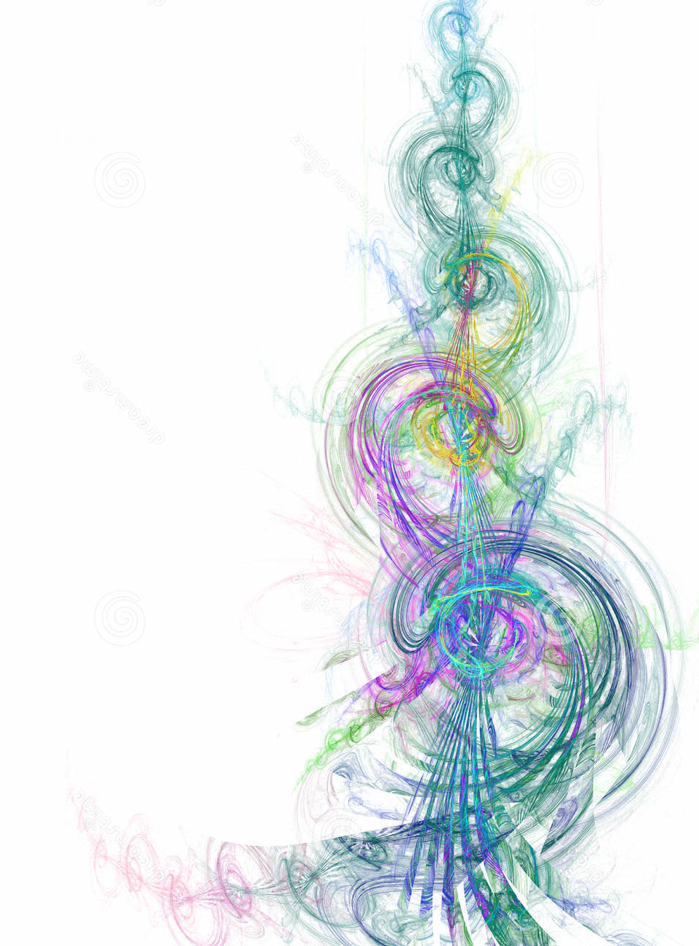

Learn How to Balance and Heal Your Body

with

Energy Medicine

Nature’s safest, most organic healing method,

uses the energy of your own hands.

Join us this year as we explore

Donna Eden’s Energy Medicine,

an amazing method for feeling

happy, healthy and more alive!

**Foundations Year 1**

**in**

**Salem, OR**

Study the fundamentals of

Eden Energy Medicine (EEM)

in a small, nurturing setting,

with

Melanie Foster,

Authorized EEM Certification Program Faculty Member.

The one-year EEM Foundations Classes give you the training you need to:

* Enhance your self –care skills and build a resilient energy system.
* Gain sufficient experience to confidently help your family and friends.
* Integrate basic EEM methods into your professional practice.
* Enroll in the Year 2 Certification Program to become an EEM Certified Practitioner.

**For more information:**

**Contact Melanie Foster**

**Phone: (310) 291-0118**

[**melanifoster@gmail.com**](mailto:melanifoster@gmail.com)

**Innersource.net**

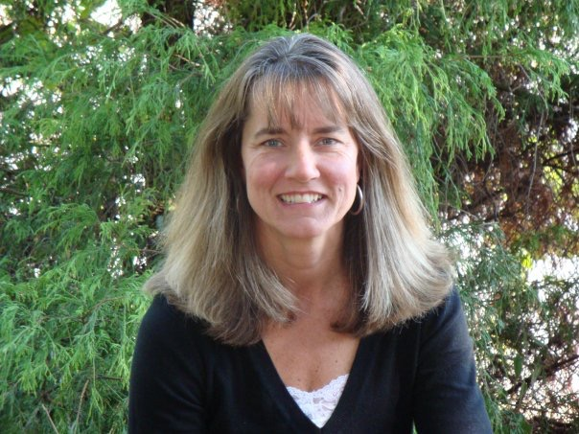

**Class Schedule**

**May 2-5, 2019**

**August 1-4, 2019**

**November 7-10, 2019**

**January 30-Feb 2, 2020**

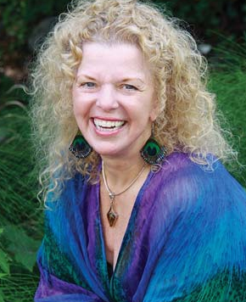Donna Eden