Unlock Your Body’s Healing Power

While the costs and complexity of healthcare continue to skyrocket, Eden Energy Medicine offers simple easy-to-learn techniques for keeping yourself healthy and vital. These hands-on tools for you, your family and friends unlock your body's natural healing power, boost immunity, and increase joy!

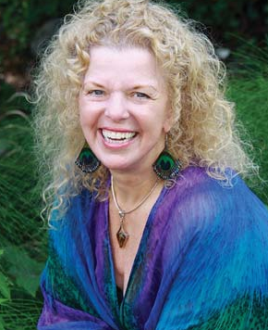While the costs and complexity of healthcare continue to skyrocket, Eden Energy Medicine offers simple easy-to-learn techniques for keeping yourself healthy and vital. These hands-on tools for you, your family and friends unlock the body's natural healing power, boost immunity, and increase joy!

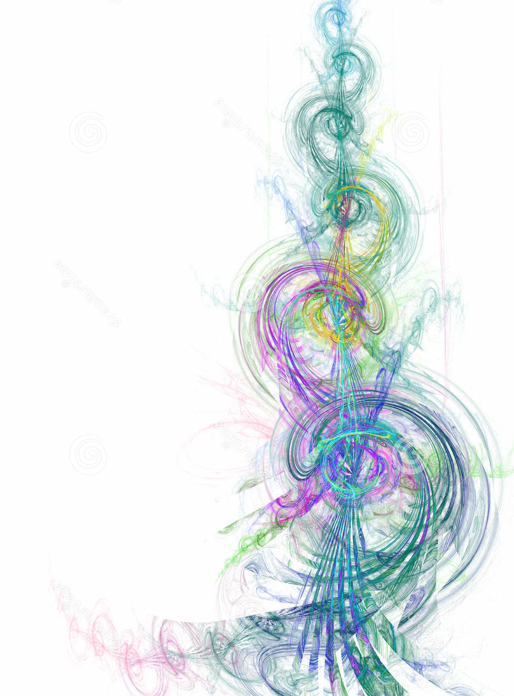

the fu

***Study the fundamentals of Eden Energy Medicine (EEM) with Sandi Roberts, an Advanced EEM Practitioner and faculty member of the EEM Certification Program. Join me at the farmhouse on an organic farm as we learn Donna Eden’s Energy Medicine – an amazing method for feeling healthy, happy and more alive!***

**Where: Frederick, MD**

**May 16 - 19, 2019**

**August 1 - 4, 2019**

**Oct 17 - 20, 2019**

**Jan 9 - 12, 2020**

**In this one year program, you will learn how to:**

* Thrive by optimizing your body’s energies.
* Facilitate healing by addressing illness at its energetic core.
* Improve your mental acuity by boosting the energies that go to your brain.
* Manage stress and distress more effectively by working with the energies involved in the stress response.
* Feel better and function more efficiently by keeping your energy flowing throughout the day.
* Make a tremendous difference for your own well-being and those you love.

**NCBTMB**

**CE’s**

**Available**

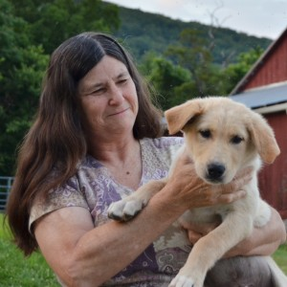

**For more information:**

**Contact: Sandi Roberts**

**301.524.2269**

[**sandir@hotmail.com**](mailto:melanifoster@gmail.com)

**www.sandiroberts.com**